A list of Supporting Information
Figure S1. Functional enrichment and PPI network analysis of DEmRNAs.
Figure S2. Kaplan–Meier overall survival analysis of selected DERNAs for all PDAC stages.
Figure S3. Kaplan–Meier survival analysis of the three selected mRNAs as determined using gene chip microarray data.
Figure S4. Diagnostic evaluation of FAM83A and hsa-miR-375.
Table S1. Diagnostic performance of hub ceRNA axis members based on ROC curve analysis in PDAC.

Supplementary Figure 1. Functional enrichment and PPI analysis of DEmRNAs. (A) The top 15 significantly enriched GO biological processes, cellular components, and molecular functions associated with the 38 DEmRNAs ranked by adjusted p-value. (B) The top 15 KEGG pathways mainly related to the 38 DEmRNAs ranked by adjusted p-value. (C) The PPI network constructed using the STRING database with an interaction confidence score of > 0.4, showing genes that occupy central network positions.

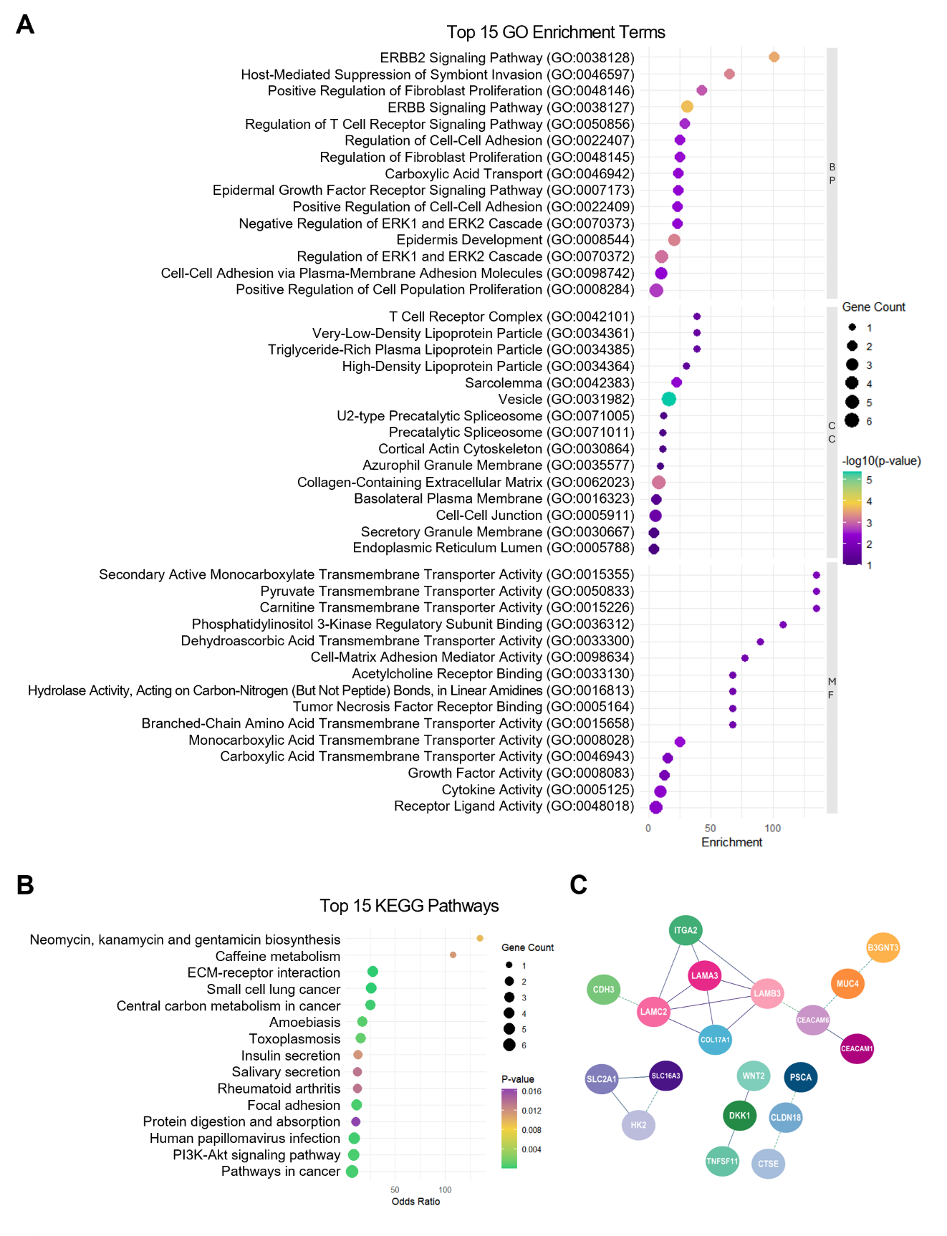

Supplementary Figure S2. Kaplan–Meier overall survival analysis of selected DERNAs across all PDAC stages. (A–E) Survival curves for the five DElncRNAs (LINC00520, LINC00857, LNCAROD, SOX21-AS1, and UCA1). (F) Survival curve for hsa-miR-375. (G–I) Survival curves for three DEmRNAs (LAMC2, SLC16A3, and FAM83A). Patients were divided into high- and low-expression groups based on median expression. Elevated DElncRNA and DEmRNA expressions were associated with shorter overall survival, whereas elevated hsa-miR-375 expression was correlated with better prognosis.

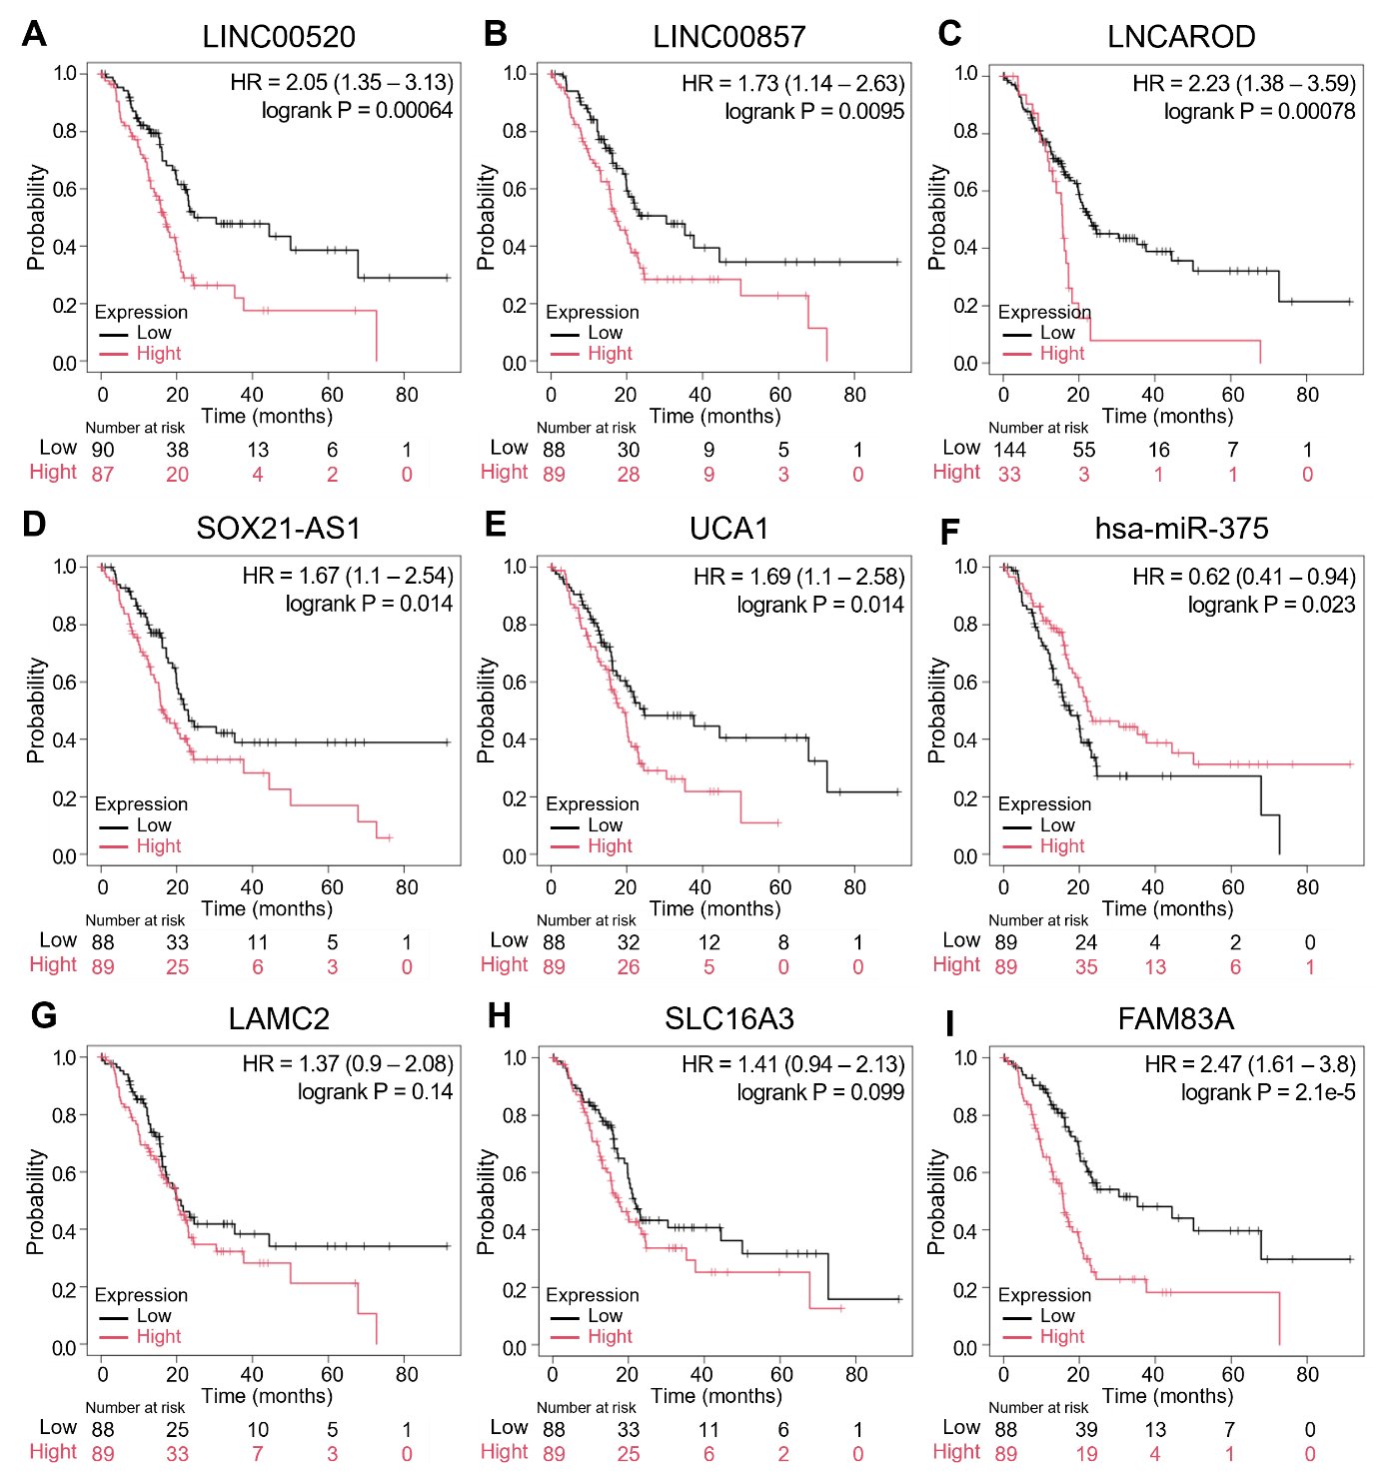

Supplementary Figure S3. Kaplan–Meier survival analysis of the three selected mRNAs as determined using gene chip microarray data. (A–C) Overall survival curves for LAMC2, SLC16A3, and FAM83A in stage I patient tissues. (D–F) Overall survival curves for LAMC2, SLC16A3, and FAM83A in all-stage patient tissues. Patients were stratified into high- and low-expression groups based on median expression, and for each gene, higher expression was associated with poorer overall survival.

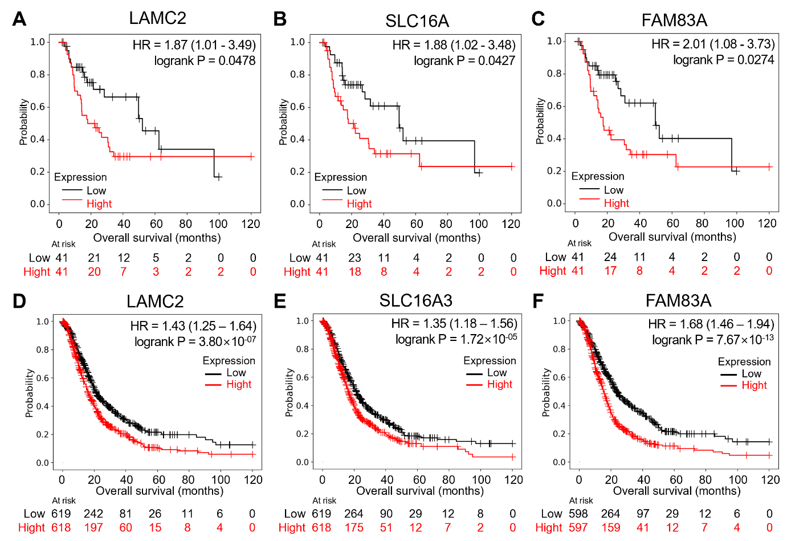

Supplementary Figure S4. Diagnostic evaluation of FAM83A and hsa-miR-375. (A) ROC curve for FAM83A in stage I patients, showing limited discriminative ability due to many missing values in the proteomic dataset. (B) ROC curve for FAM83A across all stages, demonstrating modest diagnostic performance. (C) ROC curve for hsa-miR-375 across all stages, showing potent discriminative ability.

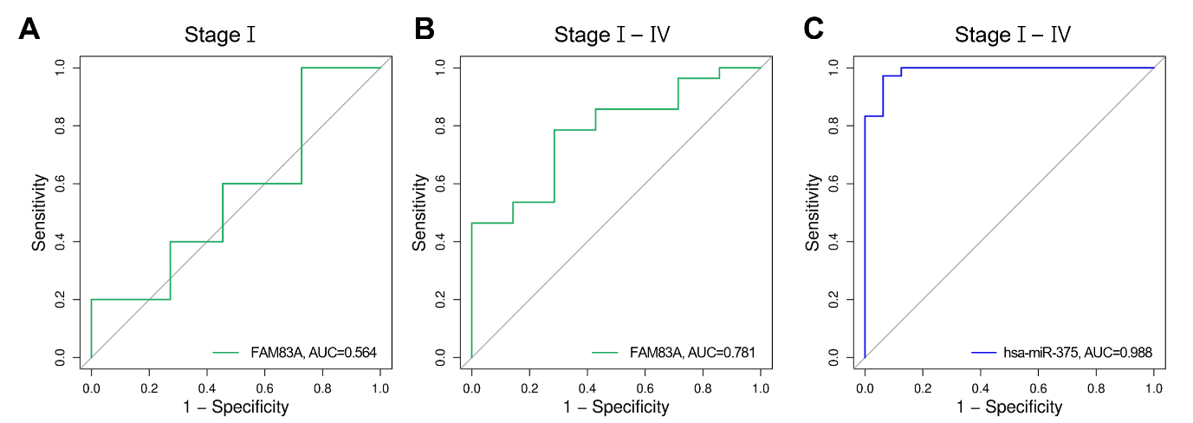

Supplementary Table S1. Diagnostic performance of key ceRNA axis members based on ROC curve analysis in PDAC.
Dataset / Gene | AUC | 95% CI | Sensitivity (%) | Specificity (%) | p-value
Transcriptome (Stage I)
LINC00857 | 0.969 | 0.92-1.00 | 87 | 100 | 2.17e-72
UCA1 | 0.859 | 0.74-0.98 | 83 | 90 | 3.42e-09
LAMC2 | 0.959 | 0.90-1.00 | 96 | 95 | 3.26e-49
SLC16A3 | 0.928 | 0.85-1.00 | 78 | 100 | 5.02e-30
FAM83A | 0.944 | 0.87-1.00 | 96 | 90 | 6.72e-34
Transcriptome (Stage I-IV)
LINC00857 | 0.971 | 0.95-1.00 | 91 | 95 | 6.37e-321
UCA1 | 0.824 | 0.74-0.91 | 76 | 90 | 6.48e-13
LAMC2 | 0.968 | 0.94-1.00 | 92 | 95 | 5.63e-247
SLC16A3 | 0.967 | 0.94-0.99 | 86 | 100 | 8.75e-287
FAM83A | 0.943 | 0.89-1.00 | 94 | 90 | 6.92e-52
has-miR-375 | 0.988 | 0.97-1.00 | 97 | 94 | 1.23e-391
Proteome (Stage I)
LAMC2 | 0.967 | 0.92-1.00 | 94 | 91 | 4.01e-102
SLC16A3 | 0.922 | 0.86-0.99 | 94 | 80 | 2.93e-36
FAM83A | 0.564 | 0.46-0.88 | 55 | 83 | 1.06e-01
Proteome (Stage I-IV)
LAMC2 | 0.982 | 0.96-1.00 | 98 | 91 | 6.9e-678
SLC16A3 | 0.925 | 0.88-0.97 | 91 | 95 | 7.84e-90
FAM83A | 0.781 | 0.56-0.82 | 65 | 70 | 3.50e-03

